VMWare Player and Cloudera QuickStart VM Installation for Windows

Daya Rudhramoorthi

Adjunct Faculty

Northeastern University

Contents

Abstract 3

A. Laptop Requirements 4

B. Required Downloads 4

C. Installation 4

D. Power On 11

E. Power Off/Shutdown 16

References 19

Abstract

This document is created as part of ALY6110 – Data Management and Big Data class. This document covers step -by-step instructions on installing VMWare Workstation player and Cloudera QuickStart for VMWare.

Note: - This document doesn’t cover installations of spark.

# Laptop Requirements

Following are the hardware (laptop) requirements to run Cloudera.

1. Need 12 GB memory, 8GB to run Cloudera VM and 4GB of your native OS (Windows).
2. Need at least 6 core CPU, 2 core to run Cloudera VM.
3. Need at least 10GB of free space. To download Cloudera VM and Sparc.

# Required Downloads

1. Download VMWare Workstation Player 15 from <https://www.vmware.com/products/workstation-player/workstation-player-evaluation.html>
2. Download Cloudera QuickStart for VMWare from cloudera-quickstart-vm-5.13.0-0-vmware from <https://downloads.cloudera.com/demo_vm/vmware/cloudera-quickstart-vm-5.13.0-0-vmware.zip>
3. Downloaded Cloudera QuickStart is compressed large file of 5.6 GB and retain this copy.
4. Below is the screen shot of both downloaded files.

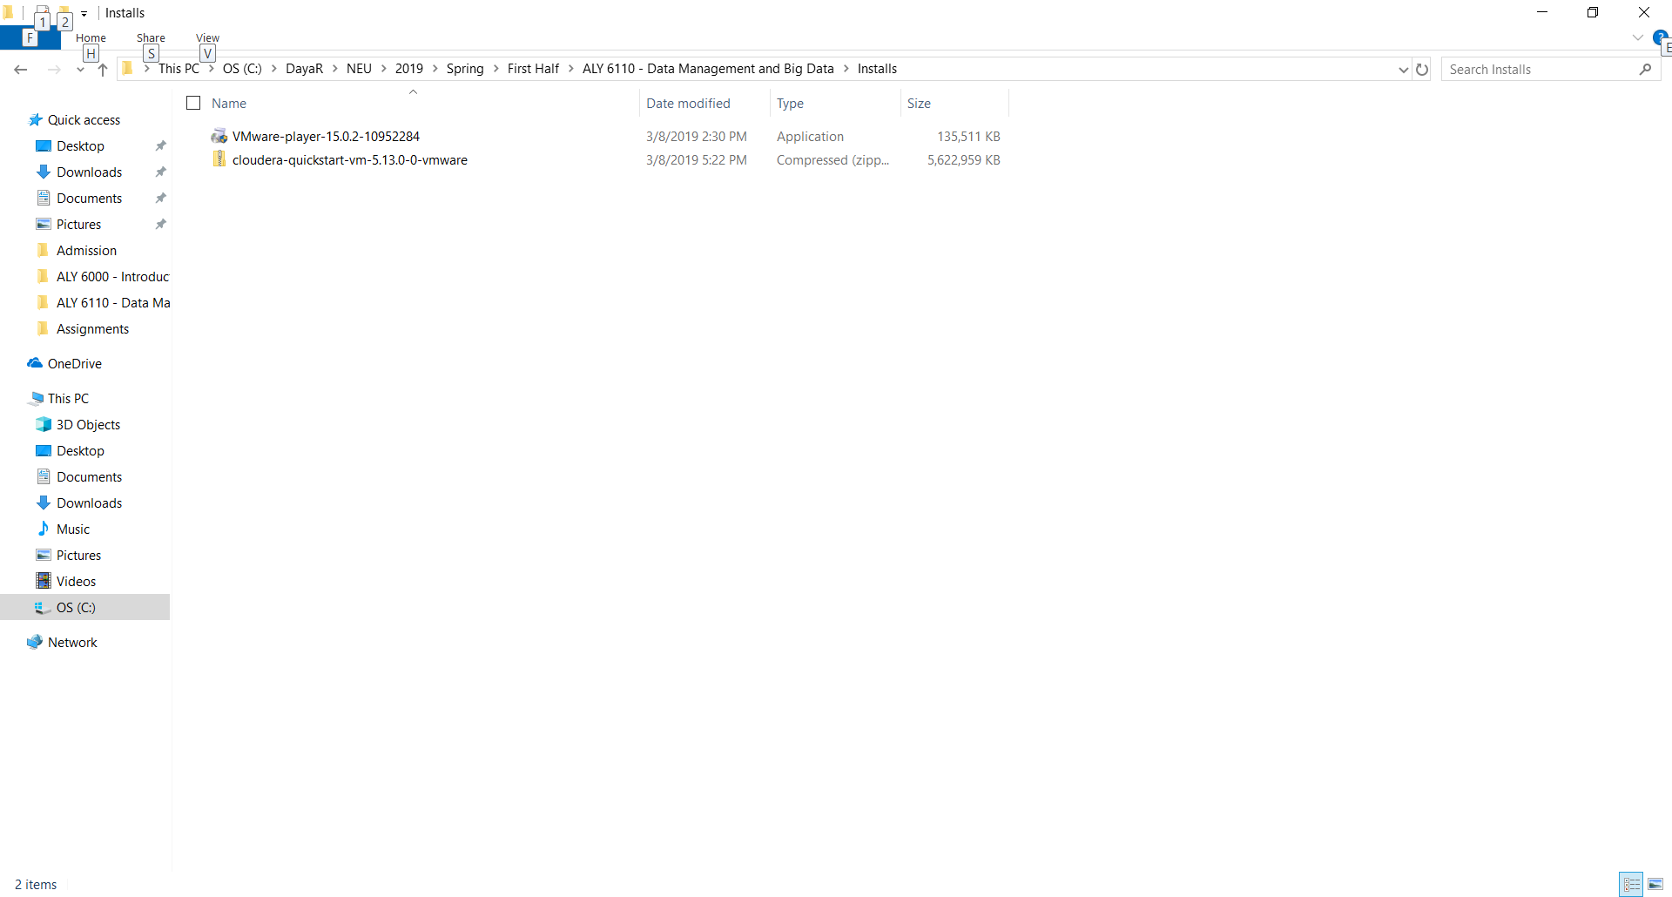

# Installation

1. Double click and Install VMWare Workstation Player 15 with Admin rights. Follow the default values during the install.
2. Unzip downloaded Cloudera QuickStart file in a new folder.

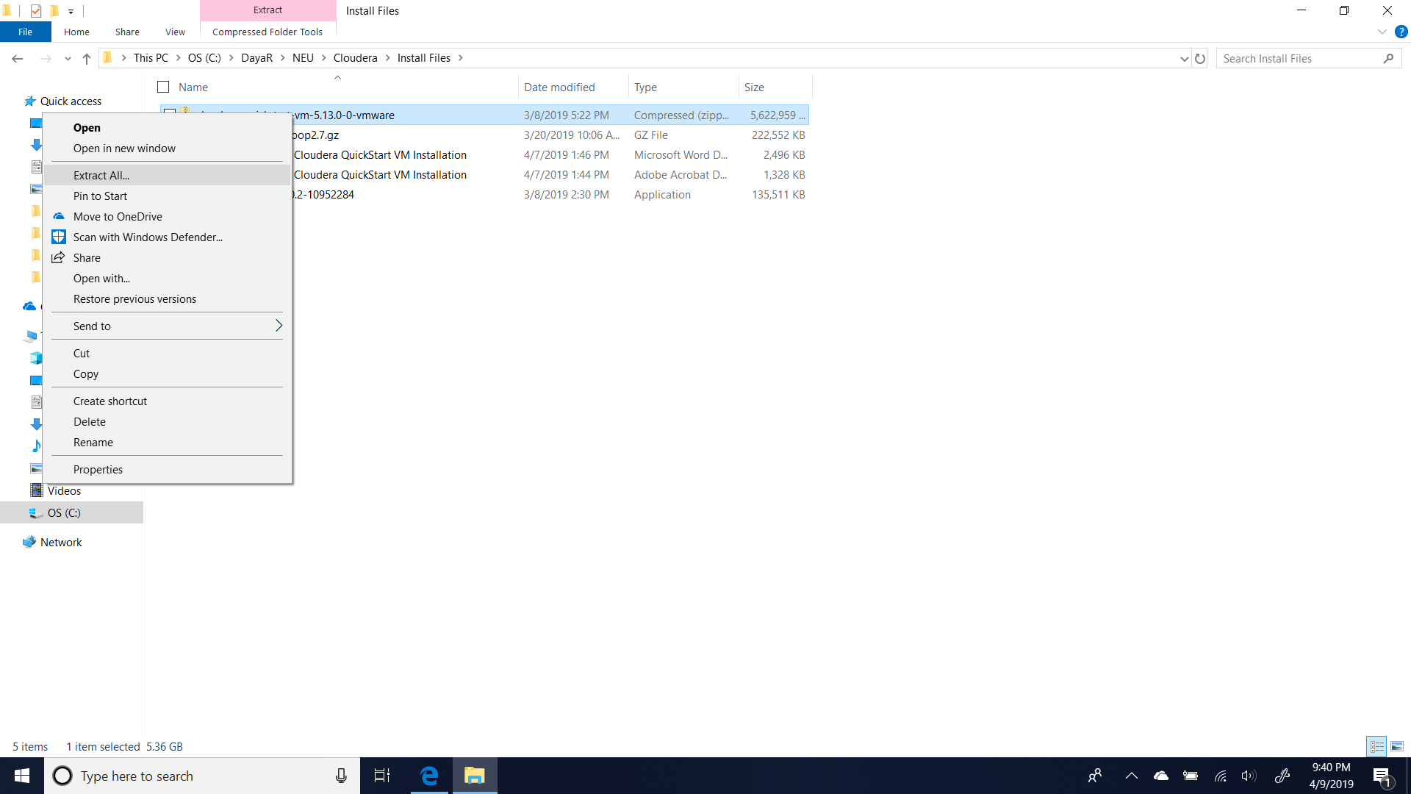

1. Below is the folder after unzip.

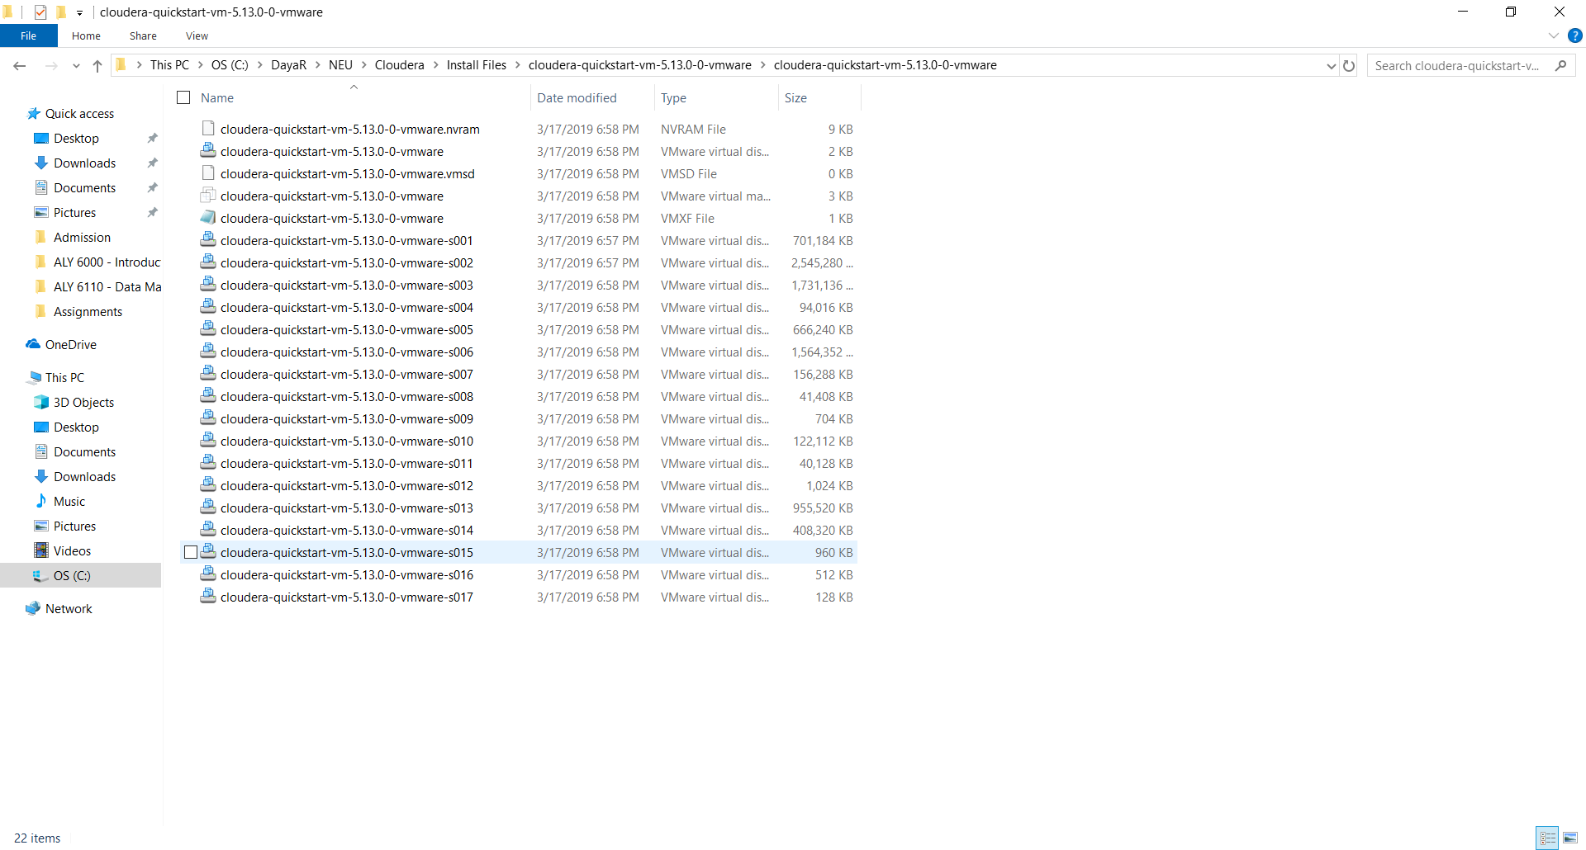

1. Double Click VMware Workstation 15 Player icon in the desktop (if you don’t see it then, VMWare in Windows Start Menu).

**NOTE: -** I have already installed and hence there is Cloudera Quickstart VM listed in the below these screenshots.

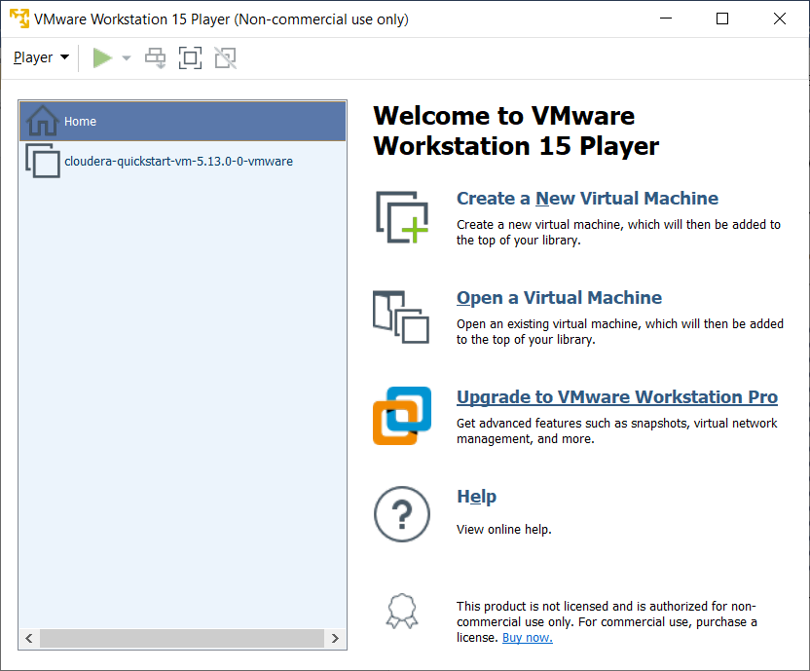

1. Click “Open a Virtual Machine” in VMWare.
2. Select the path where you unzipped Cloudera files (Step #6) and Select “cloudera-quickstart-vm-5.13.0-0-vmware” file.

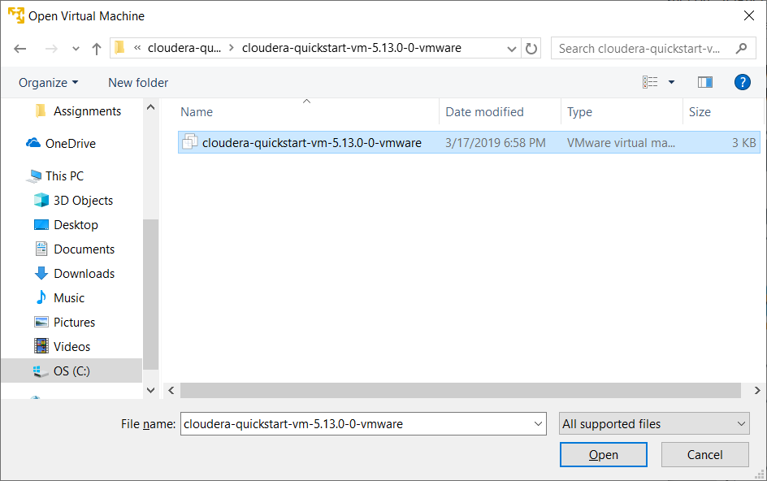

1. Select listed Cloudera Quickstart VM, right click to the properties and select “Settings”.

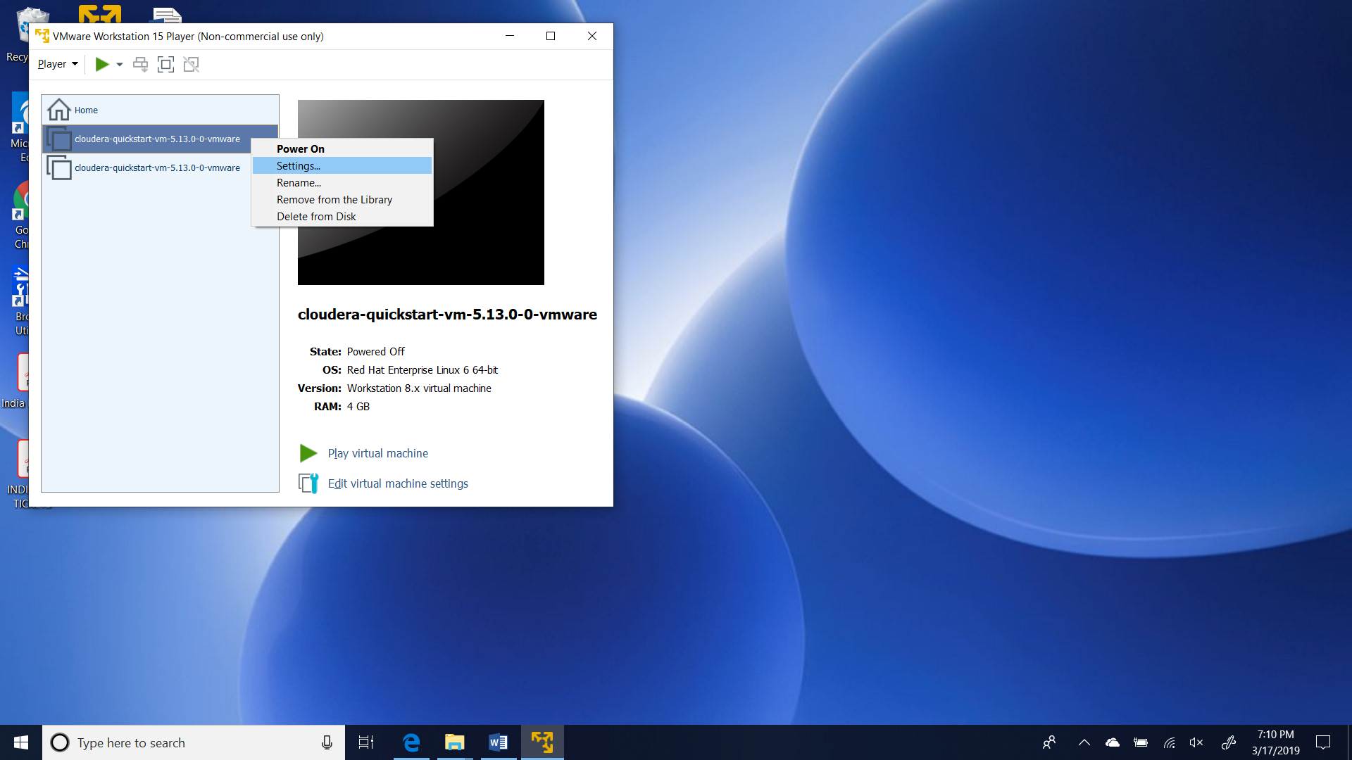

1. Below Virtual Machine Settings should display.

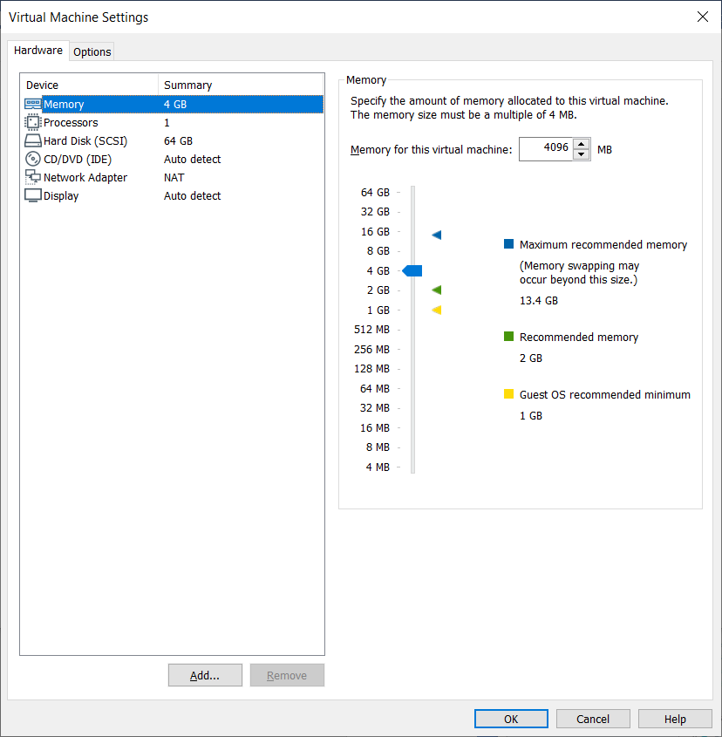

1. Increase the “Memory” to 8GB.

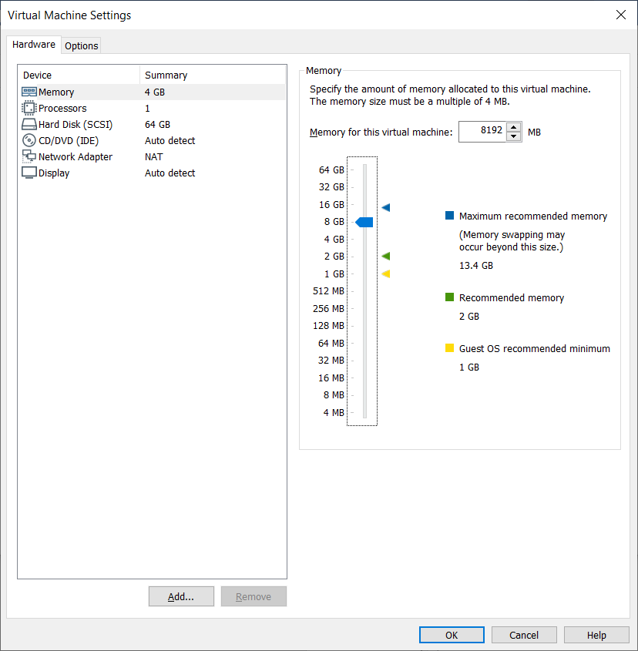

1. Select “Processors” and increase it 2.

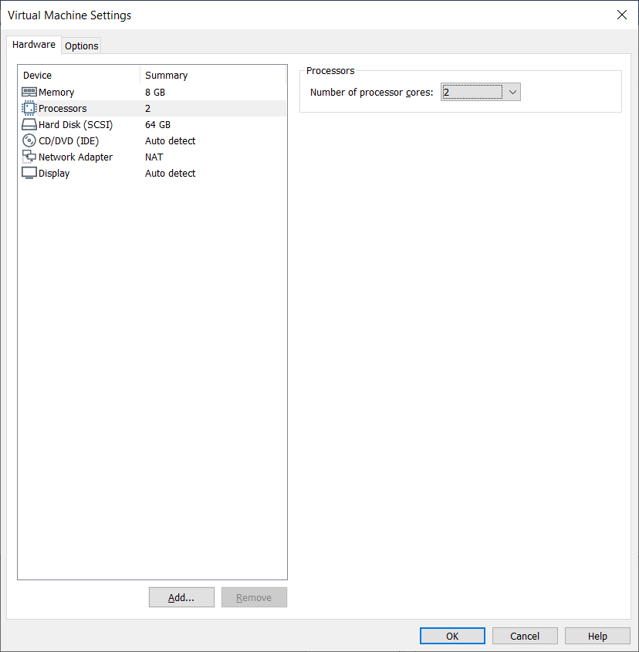

1. Click Ok.
2. After updating Memory and CPU, you should see below details if you recheck the properties.

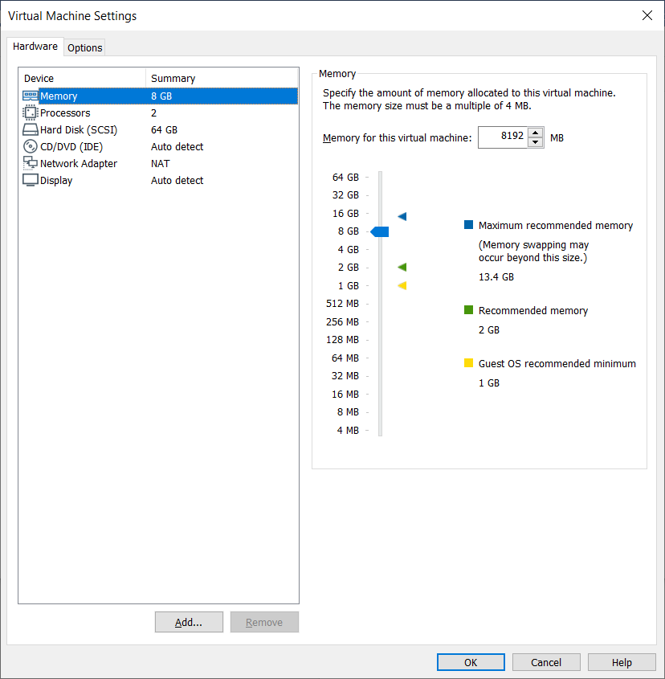

# Power On

1. Now the settings are complete for VMWare and click “Power On” in the VMWare Workstation.

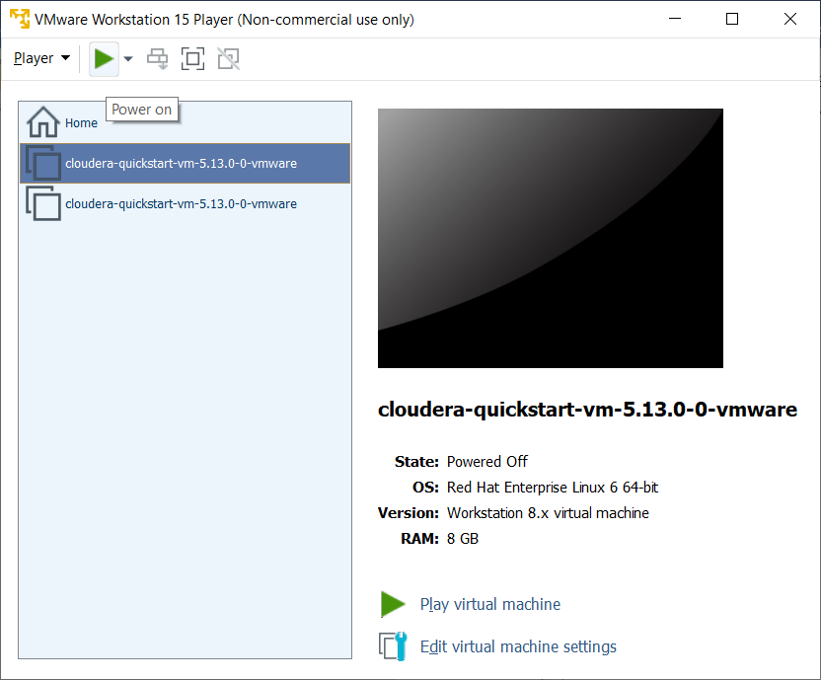

1. Since it first time, it will take bit longer and be patience.
2. After sucessful start, you will see Cludera opening in Moziall Firefox browser with Master and Worker Nodes.

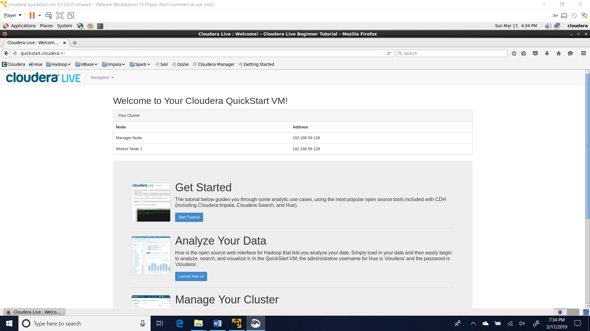

1. Click “Cloudera Manager” in Moziall Firefox browser.
2. In the Cloudera Manager page, enter cloudera as username and password to login.
3. Upon successful login into Cloudera Manager, In the “Status” tab, on the left side, you can see packages listed.

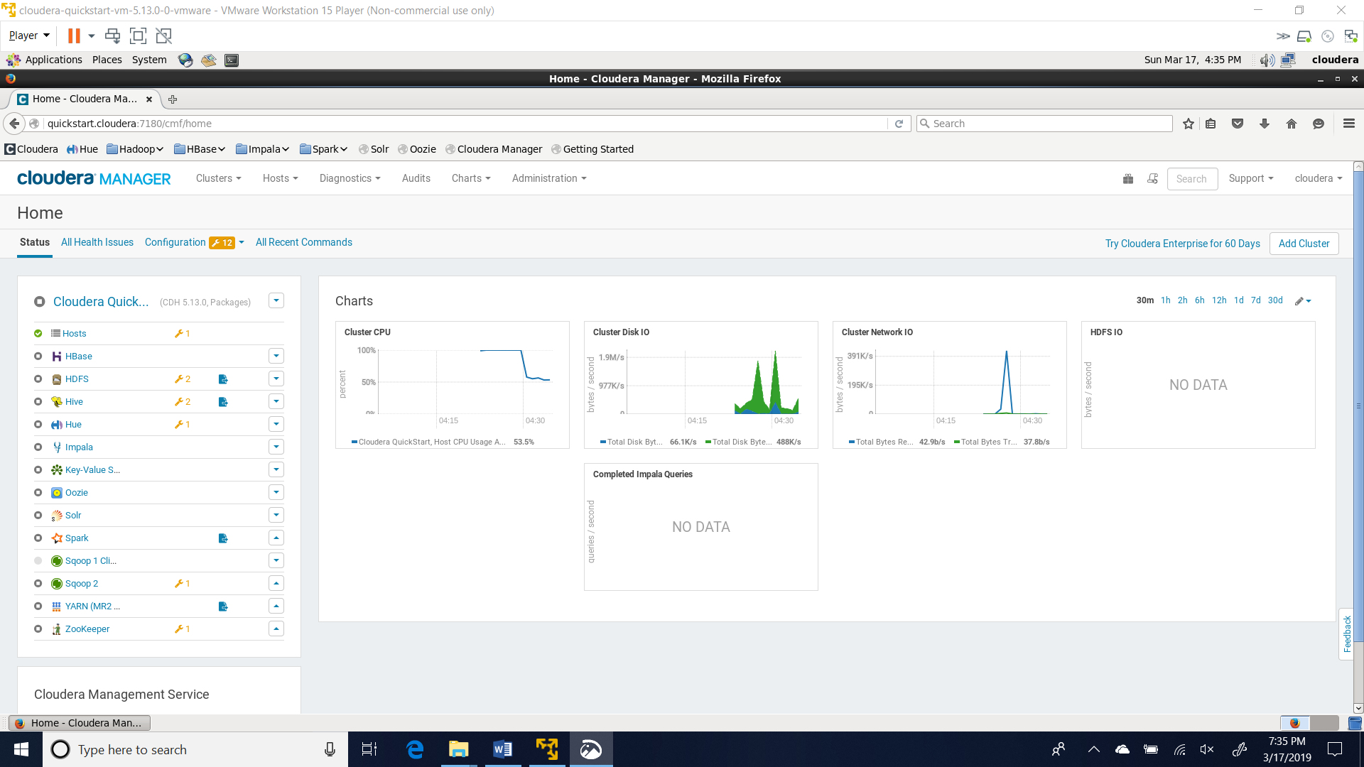

1. Select packages dropdown and click “Start”

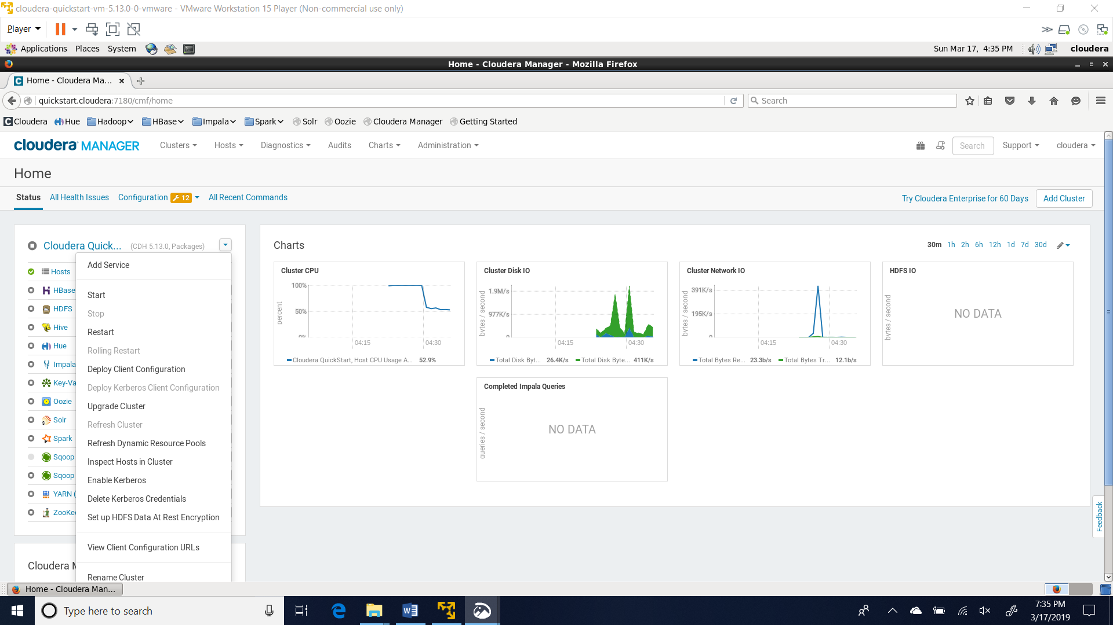

1. Confirm start message.

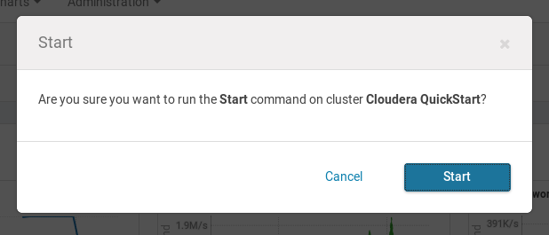

1. Be patience when all services are started.

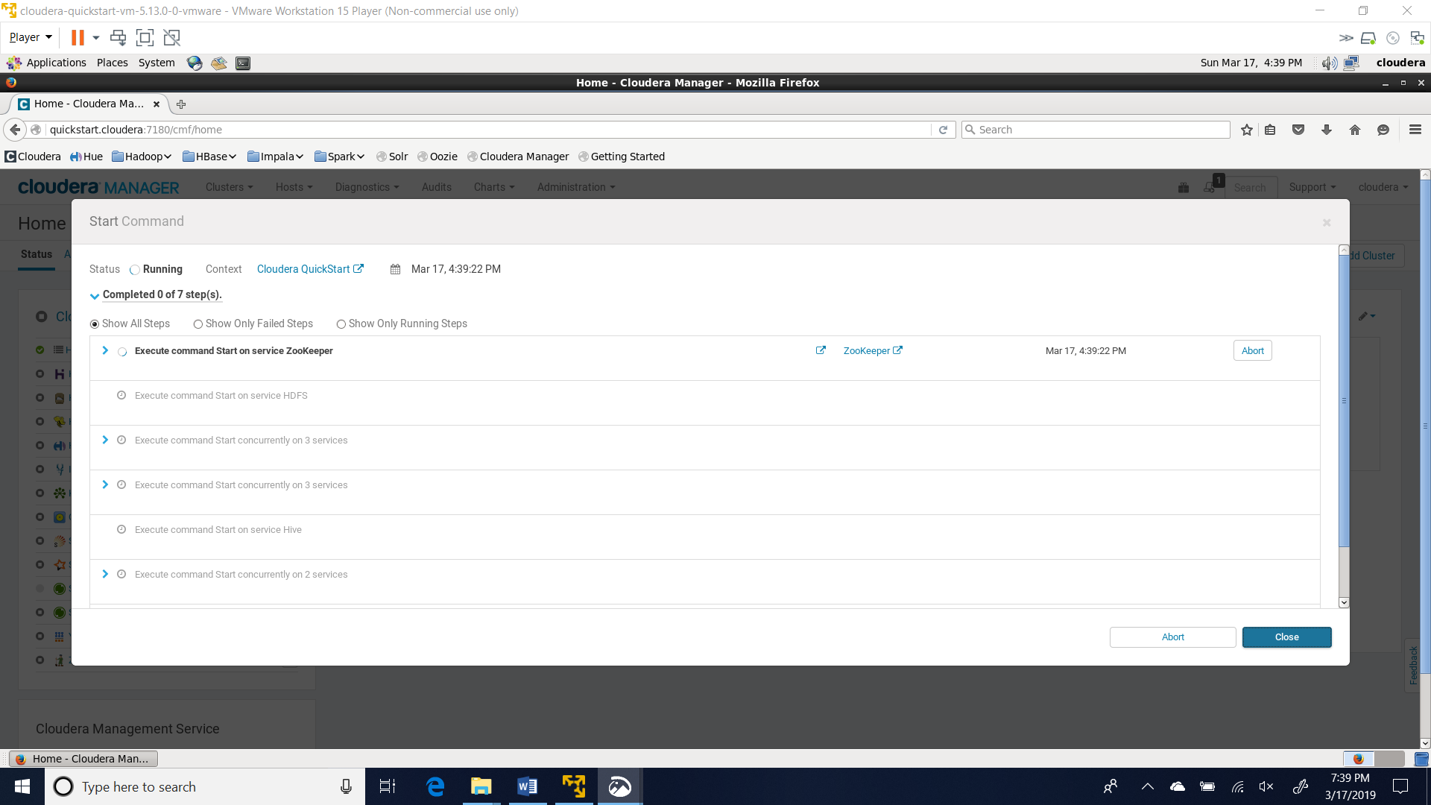

1. Below is the screen after all services are successfully started.

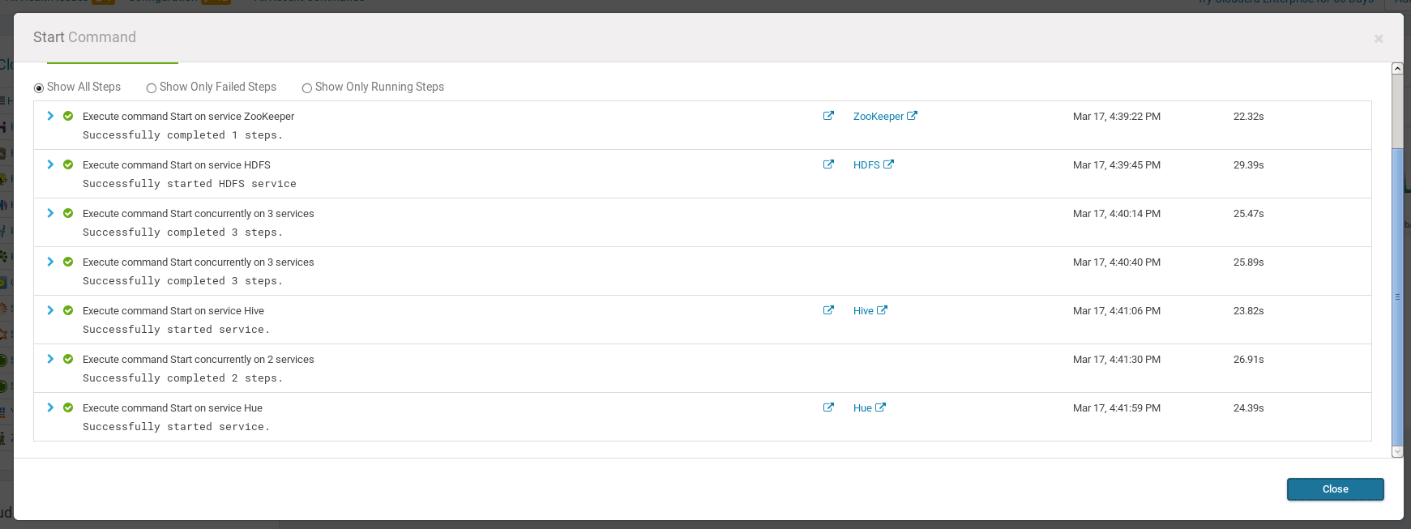

1. Main Cloudera Manager screen with all services up and running.

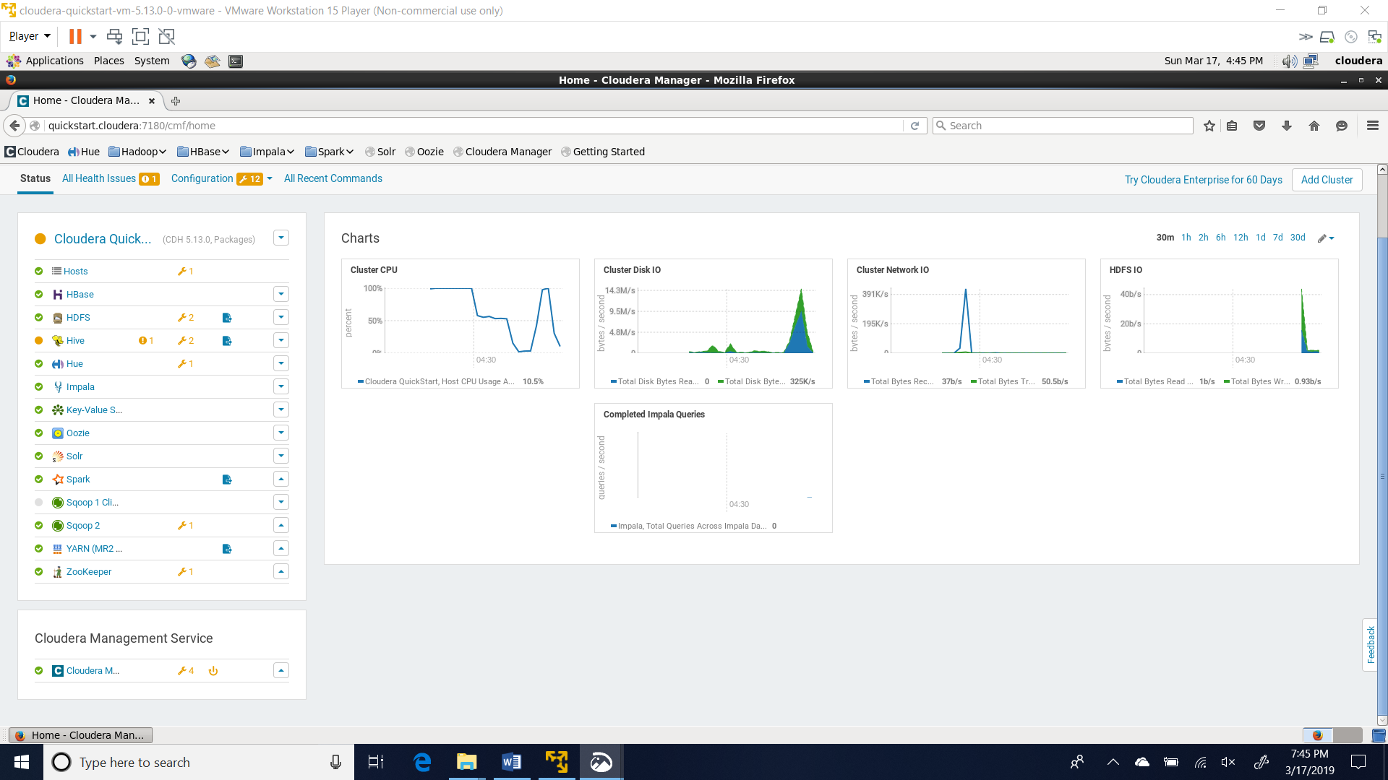

# Power Off/Shutdown

1. To Stop all services, Select “Stop” in the dropdown

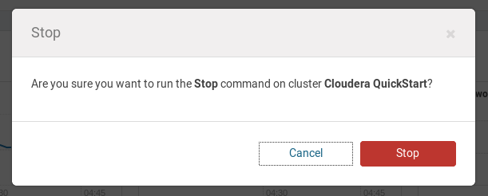

1. Wait until all services are completed stopped.
2. On the left top, next to Player, select “Shutdown Guest”

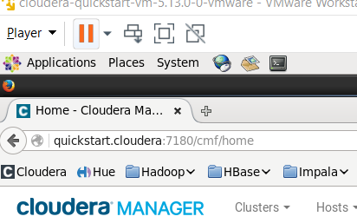

1. Confirm Shutdown message.

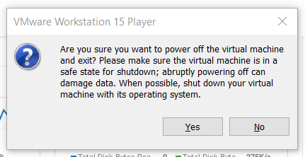

References

No Author (2019). VMWare, Retrieved from https://www.vmware.com/products/workstation-player/workstation-player-evaluation.html

No Author (2019). Cloudera, Retrieved from https://www.cloudera.com/downloads/quickstart_vms/5-13.html